**Design Diagrams**

**-**Varshitha M K (15IT151)

**Use Case Diagram**

* **Student Use Case Diagram**

Actor: Student

Description: Student login to the system and if correct credentials are given then he can view the list of all the classes else he has to login into the system again. He can post remarks about the topic which are covered in the class by the teacher which will be updated to the database.

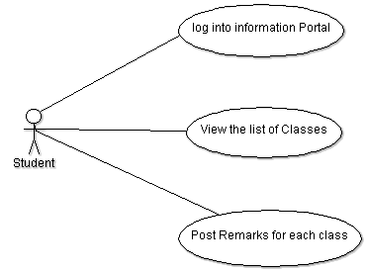

**Figure 1: Use Case diagram of a user**

* **Teacher Use Case Diagram:**

Actor: Teacher

Description: Teacher login to the system and if correct credentials are given then he can view the list of all the classes else if he has to login to the system again. He can add new batches classes also modify new classes and batches which are updated to the database.

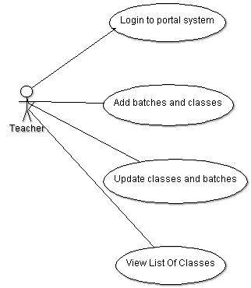

**Figure 2: Use Case diagram of a user**

**Activity Diagrams:**

## Student Activity Diagram

Student logins to the system and then username and password will be validated using the username and password information stored in the database. Once he logins to the system he views all the classes and can post the remarks on the topics discussed in the class by the teacher.

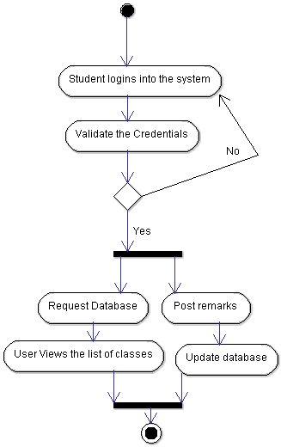

**Figure 3: Activity Diagram Of Student**

## Teacher Activity Diagram

Teacher logins to the system and then username and password will be validated using the username and password information stored in the database. Once he logins to the system he views all the classes add the new classes/batches and update classes/batches which are updated in the database.



**Figure 4: Activity Diagram of Teacher**

**Sequence Diagrams:**

## Student View Class Sequence Diagram

Student logins to the system and interacts with the interface. Then username and password will be validated using the username and password information stored in the database. Once he logins to the system he views all the classes

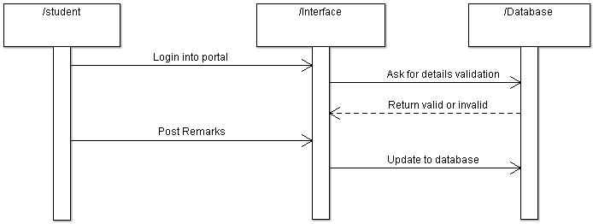

**Figure 5: Sequence Diagram-View Class List (Student)**

## Teacher View Class Sequence Diagram

Teacher logins to the system and interacts with the interface. Then username and password will be validated using the username and password information stored in the database. Once he logins to the system he views all the classes.

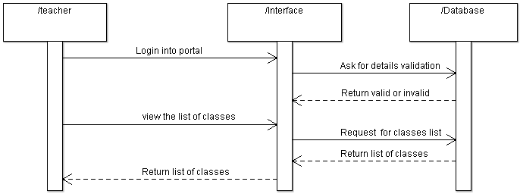

**Figure 6: Sequence Diagram -View class list**

## Student Post Remark Sequence Diagram

Student logins to the system and interacts with the interface. Then username and password will be validated using the username and password information stored in the database. Once he logins to the system he post the remarks on the topics discussed in the class by the teacher.

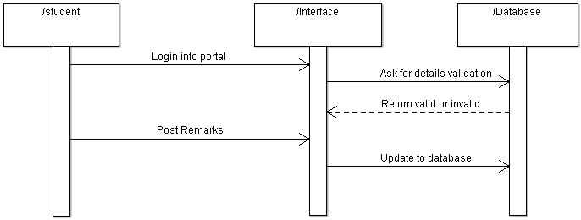

**Figure 7: Sequence Diagram-Post Remarks**

## Teacher: Add New Classes/Batches Sequence Diagram

Teacher logins to the system and interacts with the interface. Then username and password will be validated using the username and password information stored in the database. Once he logins to the system he can add new classes/batches which are updated in the database.

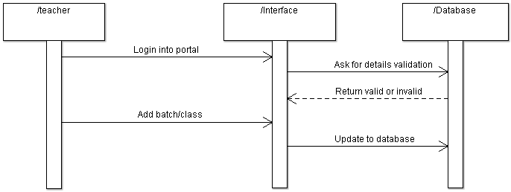

**Figure 8: Sequence Diagram-Add New Classes/Batches**

## Teacher Update Classes/Batches Sequence Diagram

Teacher logins to the system and interacts with the interface. Then username and password will be validated using the username and password information stored in the database. Once he logins to the system he can update the classes/batches which are updated in the database.

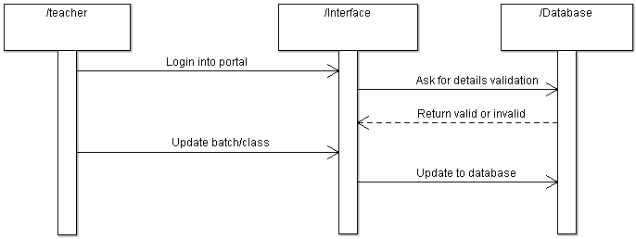

**Figure 9: Sequence Diagram-Update Classes/Batches**